Labtask 11
Visual Programming
Name: Abdulrafay Jahangir
Roll: 243504

TASK 1
Codes:
Author class
using System;
using System.Collections.Generic;
using System.Linq;
using System.Text;
using System.Threading.Tasks;

namespace Lab_11_Task_1
{
public class Author
{
public int AuthorId { get; set; }
public string? Name { get; set; }
public ICollection<Book>? Books { get; set; }

}
}

Book class
using System;
using System.Collections.Generic;
using System.Linq;
using System.Text;
using System.Threading.Tasks;

namespace Lab_11_Task_1
{
public class Book
{
public int BookId { get; set; }
public string? Title { get; set; }
public int AuthorId { get; set; }
public int CategoryId { get; set; }
public Author? Author { get; set; }
public Category? Category { get; set; }

}
}

Category class
using System;
using System.Collections.Generic;
using System.Linq;
using System.Text;
using System.Threading.Tasks;

namespace Lab_11_Task_1
{
public class Category
{
public int CategoryId { get; set; }
public string? CategoryName { get; set; }
public ICollection<Book>? Books { get; set; }
}
}

Librarycontext class
using Microsoft.EntityFrameworkCore;
using System;
using System.Collections.Generic;
using System.Linq;
using System.Text;
using System.Threading.Tasks;

namespace Lab_11_Task_1
{
public class LibraryContext:DbContext
{
public DbSet<Book> Books { get; set; }
public DbSet<Author> Authors { get; set; }
public DbSet<Category> Categories { get; set; }

protected override void OnConfiguring(DbContextOptionsBuilder optionsBuilder)
{
optionsBuilder.UseSqlServer("Data Source=DESKTOP-KUM52JP\\SQLEXPRESS;Initial Catalog=library;Integrated Security=True;Pooling=False;Encrypt=True;Trust Server Certificate=True");
}

}
}

Form code
using Microsoft.EntityFrameworkCore;
using Microsoft.EntityFrameworkCore.SqlServer;
using Microsoft.EntityFrameworkCore.Design;

namespace Lab_11_Task_1
{
public partial class Form1 : Form
{
LibraryContext context = new LibraryContext();
public Form1()
{
InitializeComponent();
context.Authors.Add(new Author { Name = "Charles Dickens" });
context.Categories.Add(new Category { CategoryName = "Fantasy" });
//context.Books.Add(new Book { Title = "HP 1", AuthorId = 7, CategoryId = 7 });
context.SaveChanges();
}

private void Form1_Load(object sender, EventArgs e)
{

}

private void button1_Click(object sender, EventArgs e)
{
var result = from b in context.Books
join a in context.Authors on b.AuthorId equals a.AuthorId
select new { b.Title, a.Name };

dataGridView1.DataSource = result.ToList();

}

private void button2_Click(object sender, EventArgs e)
{
var result = from b in context.Books
join c in context.Categories on b.CategoryId equals c.CategoryId
select new { b.Title, c.CategoryName };

dataGridView3.DataSource = result.ToList();
}

private void button3_Click(object sender, EventArgs e)
{
var result = from a in context.Authors
join b in context.Books on a.AuthorId equals b.AuthorId into bookGroup
select new { a.Name, BookCount = bookGroup.Count() };

dataGridView2.DataSource = result.ToList();
}

private void button4_Click(object sender, EventArgs e)
{
var result = from a in context.Authors
join b in context.Books on a.AuthorId equals b.AuthorId into bookGroup
from bg in bookGroup.DefaultIfEmpty()
select new { a.Name, BookName = bg.Title ?? "No Book" };

dataGridView4.DataSource = result.ToList();
}
}
}

Output:

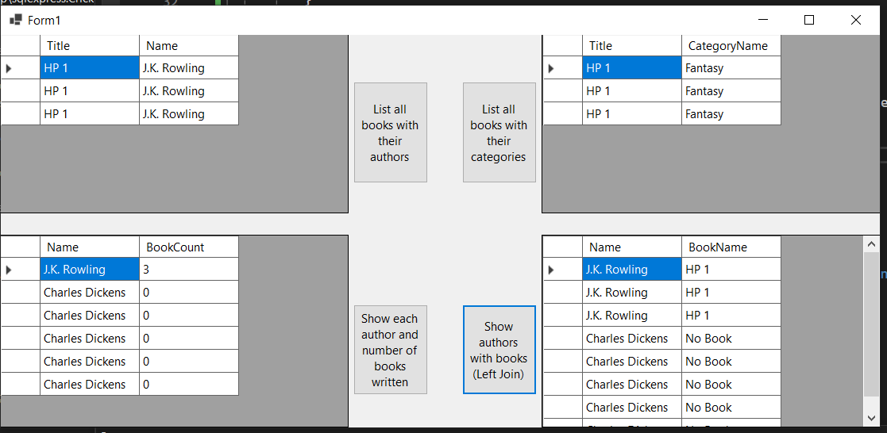

TASK 2
Codes:
HTML
@{
ViewData["Title"] = "Bio Data";
}

<h2>Student Bio Data</h2>

<table border="1" cellpadding="10">
<tr><td>Name</td><td>Abdulrafay</td></tr>
<tr><td>Father Name</td><td>Jahangir Zafar</td></tr>
<tr><td>Address</td><td>Multan, Pakistan</td></tr>
<tr><td>Degree Program</td><td>BSCS</td></tr>
<tr><td>Semester</td><td>4th</td></tr>
<tr><td>CGPA</td><td>3.92</td></tr>
</table>

Controller
using System.Diagnostics;
using Lab11_Task2.Models;
using Microsoft.AspNetCore.Mvc;

namespace Lab11_Task2.Controllers
{
public class HomeController : Controller
{
private readonly ILogger<HomeController> _logger;

public HomeController(ILogger<HomeController> logger)
{
_logger = logger;
}

public IActionResult Index()
{
return View();
}

public IActionResult Privacy()
{
return View();
}

[ResponseCache(Duration = 0, Location = ResponseCacheLocation.None, NoStore = true)]
public IActionResult Error()
{
return View(new ErrorViewModel { RequestId = Activity.Current?.Id ?? HttpContext.TraceIdentifier });
}
public IActionResult BioData()
{
return View();
}

}
}
Output:

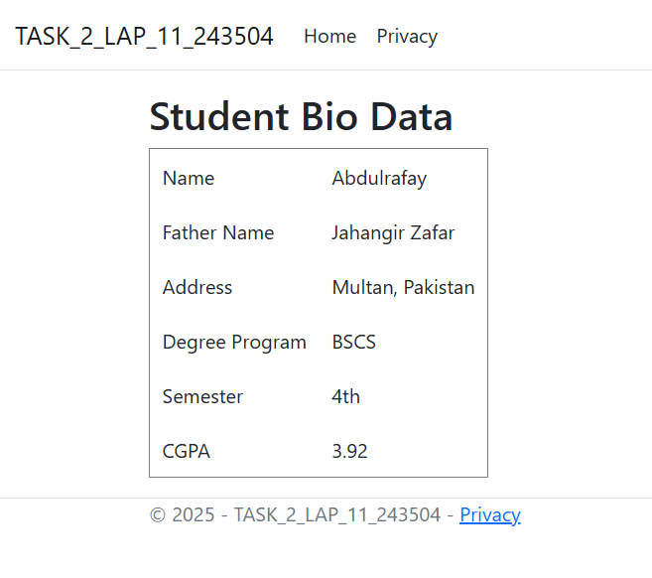
DO IT YOURSELF
CODE:
CLASSES:
SALESRECORD:
using System.Linq;
using System.Text;
using System.Threading.Tasks;

namespace TASK_1_VP_LAB_11_243504
{
public class SalesRecord
{
public int SaleID { get; set; }
public string? Date { get; set; }

public int ProductID { get; set; }
public int CustomerID { get; set; }

public Product? Product { get; set; }
public Customer? Customer { get; set; }
}
}

CUSTOMER:
using System;
using System.Collections.Generic;
using System.Linq;
using System.Text;
using System.Threading.Tasks;

namespace TASK_1_VP_LAB_11_243504
{
public class Customer
{
public int CustomerID { get; set; }
public string? Name { get; set; }

public string? City { get; set; }
public ICollection<SalesRecord>? SaleRecords { get; set; }
}
}
PRODUCT:
using System;
using System.Collections.Generic;
using System.Linq;
using System.Text;
using System.Threading.Tasks;

namespace TASK_1_VP_LAB_11_243504
{
public class Product
{
public int ProductID { get; set; }
public string? ProductName { get; set; }
public string? Category { get; set; }

public ICollection<SalesRecord> ?SaleRecords { get; set; }
}
}

DB CONTEXT :
using Microsoft.EntityFrameworkCore;

using System;
using System.Collections.Generic;
using System.Linq;
using System.Text;
using System.Threading.Tasks;

namespace TASK_1_VP_LAB_11_243504
{
public class SmartContext : DbContext
{
public DbSet<Customer> C { get; set; }
public DbSet<Product> P { get; set; }
public DbSet<SalesRecord> S { get; set; }

protected override void OnConfiguring(DbContextOptionsBuilder optionsBuilder)
{
optionsBuilder.UseSqlServer("Data Source=DESKTOP-BFCU980\\SQLEXPRESS;Initial Catalog=Mart;Integrated Security=True;Pooling=False;Encrypt=True;Trust Server Certificate=True");
}

protected override void OnModelCreating(ModelBuilder modelBuilder)
{
modelBuilder.Entity<Customer>()
.HasKey(c => c.CustomerID);
modelBuilder.Entity<Product>()
.HasKey(p => p.ProductID);
modelBuilder.Entity<SalesRecord>()
.HasKey(s => s.SaleID);

base.OnModelCreating(modelBuilder);
}
}
}

FORM DESIGN:
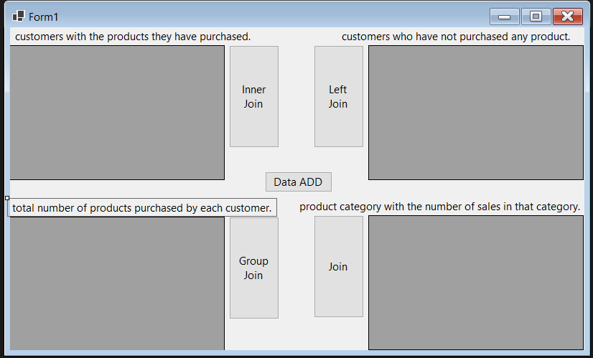

FORM CS:
using Microsoft.EntityFrameworkCore.SqlServer;
using Microsoft.EntityFrameworkCore;
using Microsoft.EntityFrameworkCore.Design;

namespace TASK_1_VP_LAB_11_243504
{
public partial class Form1 : Form
{
SmartContext context = new SmartContext();
public Form1()
{
InitializeComponent();
}

private void Form1_Load(object sender, EventArgs e)
{

}

private void button1_Click(object sender, EventArgs e)
{
var result1 =
from c in context.C
join s in context.S on c.CustomerID equals s.CustomerID
join p in context.P on s.ProductID equals p.ProductID
select new
{
CustomerName = c.Name,
City = c.City,
ProductName = p.ProductName,
SaleDate = s.Date
};

dataGridView1.DataSource = result1.ToList();
}

private void button2_Click(object sender, EventArgs e)
{
var result2 =
from c in context.C
join s in context.S on c.CustomerID equals s.CustomerID into saleGroup
from sg in saleGroup.DefaultIfEmpty()
join p in context.P on sg.ProductID equals p.ProductID into prodGroup
from pg in prodGroup.DefaultIfEmpty()
select new
{
CustomerName = c.Name,
City = c.City,
ProductName = pg != null ? pg.ProductName : "No Purchase",
SaleDate = sg != null ? sg.Date : null
};

dataGridView2.DataSource = result2.ToList();

}

private void button3_Click(object sender, EventArgs e)
{

var result3 =
from c in context.C
join s in context.S on c.CustomerID equals s.CustomerID into saleGroup
select new
{
CustomerName = c.Name,
TotalPurchasedProducts = saleGroup.Count()
};

dataGridView3.DataSource = result3.ToList();
}

private void button4_Click(object sender, EventArgs e)
{
var result4 =
from p in context.P
join s in context.S on p.ProductID equals s.ProductID
group s by p.Category into g
select new
{
Category = g.Key,
TotalSales = g.Count()
};

dataGridView4.DataSource = result4.ToList();

}

private void button5_Click(object sender, EventArgs e)
{

// Insert Customers (AUTO ID)
context.C.Add(new Customer { Name = "Ali", City = "Lahore" });
context.C.Add(new Customer { Name = "Rafay", City = "Multan" });
context.C.Add(new Customer { Name = "Ahmed", City = "Karachi" });

// Insert Products (AUTO ID)
context.P.Add(new Product { ProductName = "Laptop", Category = "Electronics" });
context.P.Add(new Product { ProductName = "Mobile", Category = "Electronics" });
context.P.Add(new Product { ProductName = "Shoes", Category = "Fashion" });

context.SaveChanges(); // IDs are generated automatically here!

// Now fetch generated IDs
var customer1 = context.C.FirstOrDefault(c => c.Name == "Ali");
var customer2 = context.C.FirstOrDefault(c => c.Name == "Rafay");

var product1 = context.P.FirstOrDefault(p => p.ProductName == "Laptop");
var product2 = context.P.FirstOrDefault(p => p.ProductName == "Mobile");

// Insert Sales using generated IDs
context.S.Add(new SalesRecord { CustomerID = customer1.CustomerID, ProductID = product1.ProductID, Date = "23"});
context.S.Add(new SalesRecord { CustomerID = customer2.CustomerID, ProductID = product2.ProductID, Date = "22" });

context.SaveChanges();

MessageBox.Show("Sample Data Inserted Successfully!");
}

}

}

CREATED DB:
using Microsoft.EntityFrameworkCore.Migrations;

#nullable disable

namespace TASK_1_VP_LAB_11_243504.Migrations
{
/// <inheritdoc />
public partial class createDb : Migration
{
/// <inheritdoc />
protected override void Up(MigrationBuilder migrationBuilder)
{
migrationBuilder.CreateTable(
name: "C",
columns: table => new
{
CustomerID = table.Column<int>(type: "int", nullable: false)
.Annotation("SqlServer:Identity", "1, 1"),
Name = table.Column<string>(type: "nvarchar(max)", nullable: true),
City = table.Column<string>(type: "nvarchar(max)", nullable: true)
},
constraints: table =>
{
table.PrimaryKey("PK_C", x => x.CustomerID);
});

migrationBuilder.CreateTable(
name: "P",
columns: table => new
{
ProductID = table.Column<int>(type: "int", nullable: false)
.Annotation("SqlServer:Identity", "1, 1"),
ProductName = table.Column<string>(type: "nvarchar(max)", nullable: true),
Category = table.Column<string>(type: "nvarchar(max)", nullable: true)
},
constraints: table =>
{
table.PrimaryKey("PK_P", x => x.ProductID);
});

migrationBuilder.CreateTable(
name: "S",
columns: table => new
{
SaleID = table.Column<int>(type: "int", nullable: false)
.Annotation("SqlServer:Identity", "1, 1"),
Date = table.Column<string>(type: "nvarchar(max)", nullable: true),
ProductID = table.Column<int>(type: "int", nullable: false),
CustomerID = table.Column<int>(type: "int", nullable: false)
},
constraints: table =>
{
table.PrimaryKey("PK_S", x => x.SaleID);
table.ForeignKey(
name: "FK_S_C_CustomerID",
column: x => x.CustomerID,
principalTable: "C",
principalColumn: "CustomerID",
onDelete: ReferentialAction.Cascade);
table.ForeignKey(
name: "FK_S_P_ProductID",
column: x => x.ProductID,
principalTable: "P",
principalColumn: "ProductID",
onDelete: ReferentialAction.Cascade);
});

migrationBuilder.CreateIndex(
name: "IX_S_CustomerID",
table: "S",
column: "CustomerID");

migrationBuilder.CreateIndex(
name: "IX_S_ProductID",
table: "S",
column: "ProductID");
}

/// <inheritdoc />
protected override void Down(MigrationBuilder migrationBuilder)
{
migrationBuilder.DropTable(
name: "S");

migrationBuilder.DropTable(
name: "C");

migrationBuilder.DropTable(
name: "P");
}
}
}

OUTPUT:
INNER JOIN
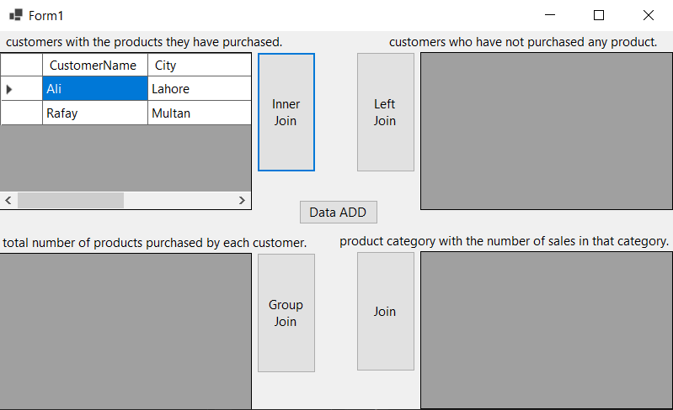
LEFT JOIN:
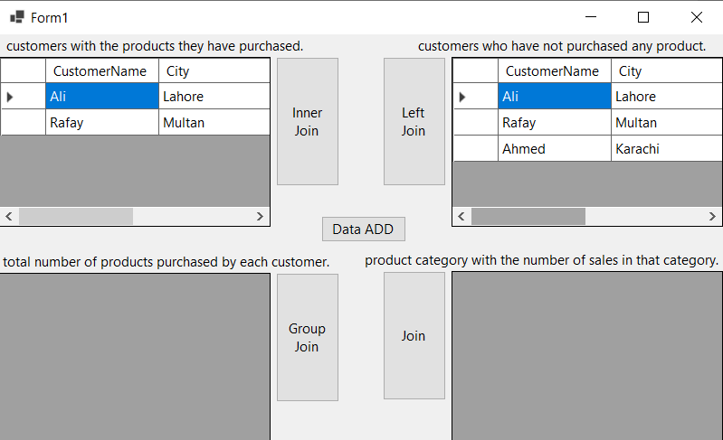
GROUP JOIN:

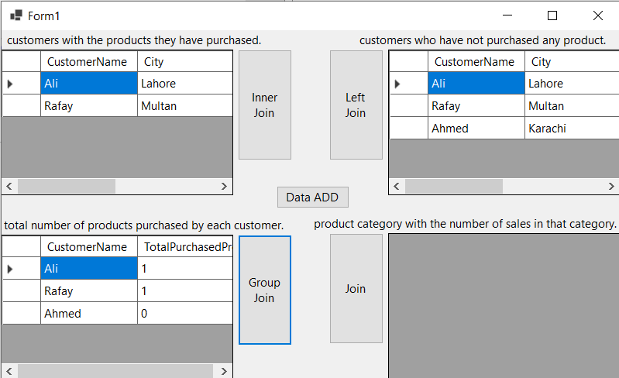
JOIN:

